CONTACT US ⏐⏐

◼ MAIL

PO BOX 405

VALLEY PARK, MO 63088

◼ PHONE

618.580.0770

◼ EMAIL

INFO@YOUAREACHAMPION.ORG

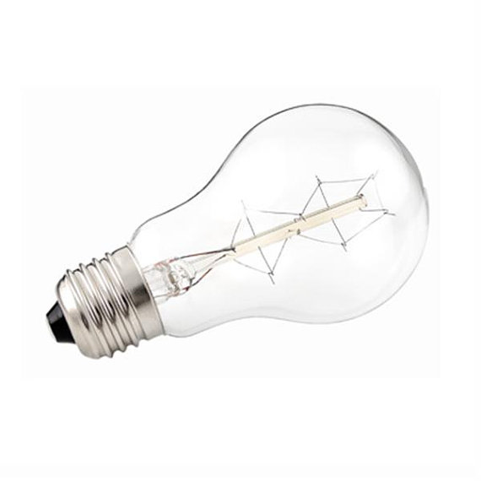

**ILLUMINATE-LIVING IN THE SHADOW ⏐⏐ 11.23.2013**

◼ John 1:5 (NLT), “The light shines in the darkness, and the darkness can never extinguish it.”

◼ Genesis 1:26, “And God said, Let us make man in our __________________, after our __________________...”

◼ Mankind was designed in the “shadow” or “__________________” of God. We must continue to live in that shadow (Psalm 91:1).

◼ His shadow is a place of _________________ (Psalm 57:1).

◼ His shadow is a place of _________________ (Isaiah 25:4).

◼ His shadow is a place of _________________ (Psalm 36:7).

◼ His shadow is a place of _________________ (Psalm 17:8).

◼ His shadow is a place of _________________ (Isaiah 49:1-2).

◼ His shadow is a place of _________________,_________________, and _________________

(Isaiah 51:16).

◼ His shadow is a place of __________________ (Psalm 63:7).

◼ __________________ is that Shadow!

Isaiah 32:1-3, “Behold, a king shall reign in righteousness, and princes shall rule in judgment. And a man shall be as an hiding place from the wind, and a covert from the tempest; as rivers of water in a dry place, as the shadow of a great rock in a weary land. And the eyes of them that see shall not be dim, and the ears of them that hear shall hearken.”

**CHAMPIONSCHURCH**

**WWW.YOUAREACHAMPION.ORG**

**◼◼◼◼◼◼◼◼◼**

**◼ FEEDING THOSE IN NEED ⏐⏐** We are joining with Joan Gieson Ministries to feed families in our region. Please bring in canned goods to help this Christmas outreach.

**◼ IT’S BEGINNING TO LOOK A LOT LIKE… ⏐⏐** Our Church Christmas party will be Sunday, December 22. Details to come. We will also be joining with Gateway:61 for our Christmas Eve Service, Tuesday, December 24, at 6:00PM.